P1-Pothole Tracking and Repair

Prasant Kumar (2018MB12036)

Kulsharest Jain (2018MB12006)

Navneet Thillaisthanam (2018MB12030)

Nishant Kumar (2018MB12016)

**INDEX**

1. Project: P1 - Pothole Tracking and Repair 4

1.1. Requirement: 4

2. Identify Actors and Use Cases 4

2.1. Login and Authentication: 4

2.2. Report Pothole: 4

2.3. Work Assignment: 4

2.4. Work Progress and Tracking: 4

2.5. Review and Feedback: 5

3. Fully Dressed Use Cases 7

3.1. UC1: Login and Authentication: 7

3.2. UC1:Report Pothole: 10

**Revision Control**

|  |  |  |  |
| --- | --- | --- | --- |
| **Revision No.** | **Reason for Change** | **Revision Date** | **Changes Done** |
| V1.0 | First Draft Of Project | 20/10/2018 | UC Identification, and 2 UC Fully Dressed |
|  |  |  |  |
|  |  |  |  |
|  |  |  |  |
|  |  |  |  |
|  |  |  |  |

**Reference:**

UML Book: Applying UML and Patterns 3rd edition

UML Tool: ArgoUML V0.34

## Project: P1 - Pothole Tracking and Repair

## Requirement:

Bangalore Mayor has promised to repair all the potholes in the city with citizen participation.

You are IT implementation partner to BBMP for web based or smartphone app based (or both) Pothole Tracking and Repair system. Citizens will report the potholes with a GPS Map location and a photograph. BBMP will assign pothole repair work to a Contractor. Contractor will provide a cost estimate along with a photograph and size confirmation of the pothole. The software will calculate the pothole size from photograph and cross check with the details submitted by Contractor. BBMP will approve the cost estimate and Contractor will perform the work. Citizen who have reported pothole will be able to report their satisfaction on repair work. Contracts will be assigned by area - constituency / wards / pin code. Contractor will be paid on a monthly basis. A Google Map integrated navigation of potholes with their status will be provided. The Mayor should be able to visualize the progress for overall city or by an area - constituency / pin code or by individual roads.

## Identify Actors and Use Cases

## Login and Authentication:

**Actors:** Citizen, BBMP, Contractor

**Use Case:** System shall have login/logout feature for all users and for accessing the system, a user has to input login credentials such UserID and Password. While creating profile of Citizen and Contractor, the system shall have personal details of the user. BBMP shall have admin rights to make changes in data stored in the system.

## Report Pothole:

**Actors:** Citizen

**Use Case:** The Citizens can report the potholes with a GPS Map location and a photograph of the pothole. A Google Map will be integrated for reporting pothole

## Work Assignment:

**Actors:** BBMP, Contractor

**Use Case:** BBMP will assign pothole repair work to a Contractor. Further, the contractor will provide a cost estimate along with a photograph and size confirmation of the pothole. The software will automatically calculate the pothole size from photograph and cross check with the details submitted by Contractor. BBMP will approve the cost estimate and the contractor will perform the work assigned. Contracts will be assigned by area - constituency / wards / pin code. The contractor will be paid on a monthly basis.

## Work Progress and Tracking:

**Actors:** Citizen, BBMP, Contractor

**Use Case:** Citizens/BBMP/Contractors can track their request with unique ReqID generated by the system. With navigation of potholes their status will be provided. The Mayor should be able to visualize the progress for overall city or by an area - constituency / pin code or by individual roads.

## Review and Feedback:

**Actors:** Citizen, BBMP, Contractor

**Use Case:** BBMP can review work quality and provide feedback to the Contractor.Citizen who have reported pothole will be able to report their satisfaction on repair work, with review and feedback. BBMP can reassign work to the contractor (Or other Contractor).

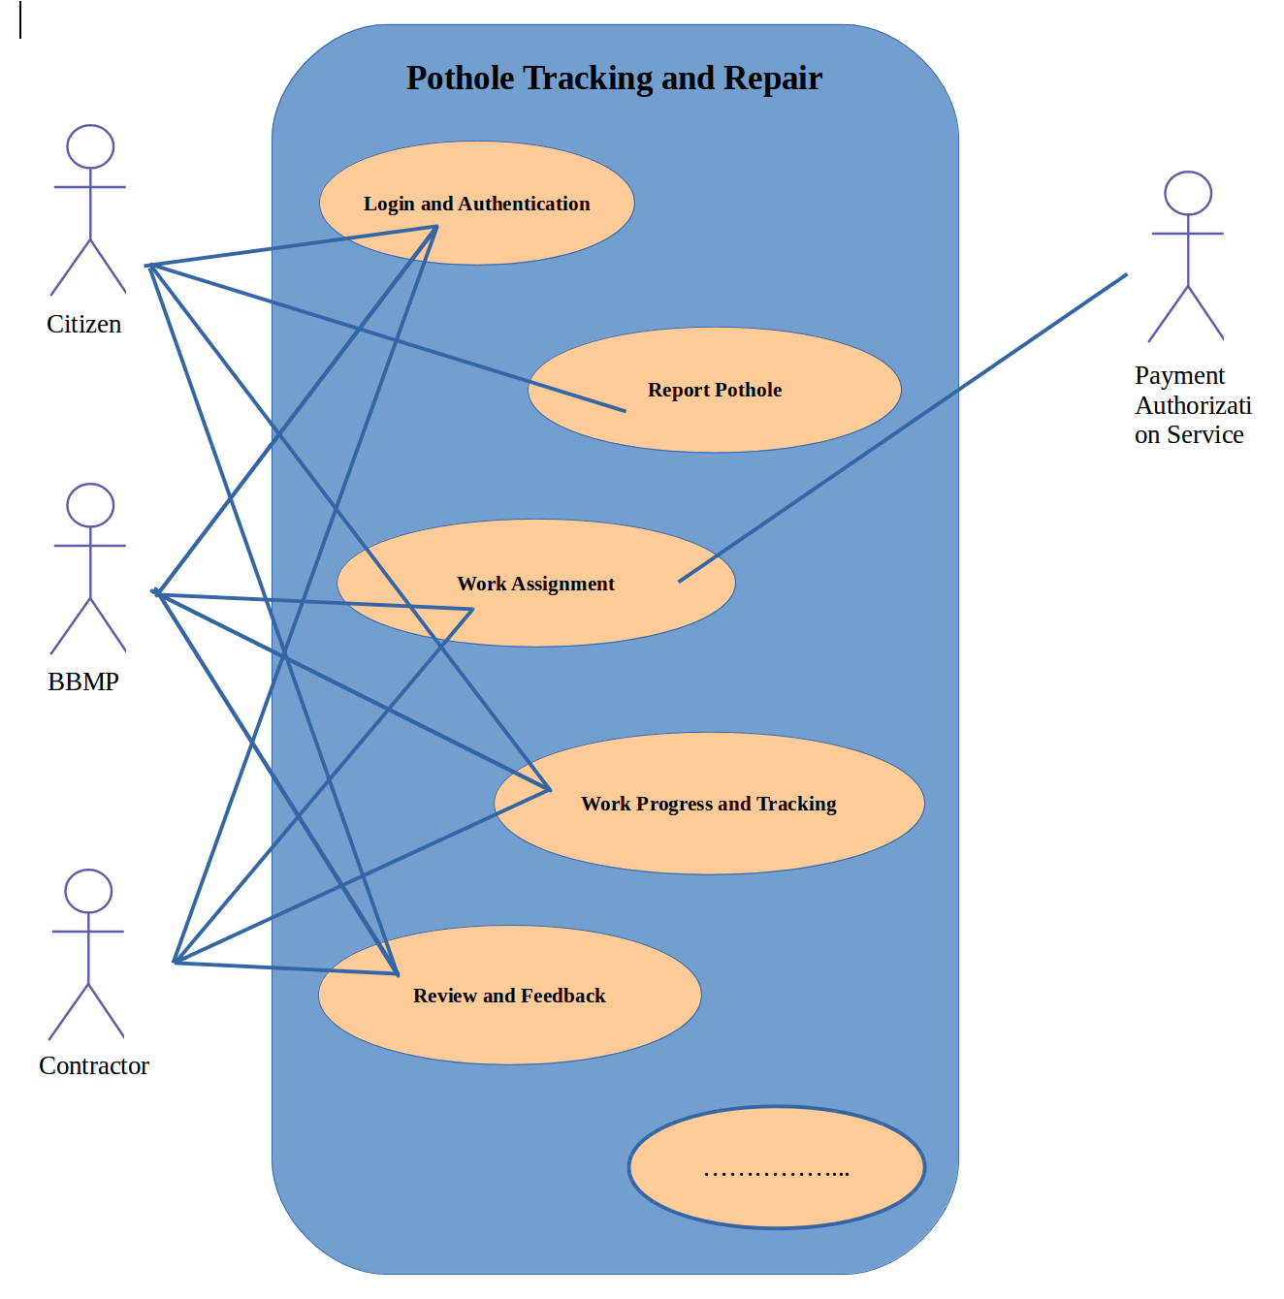

**Partial use case context diagram**

## Fully Dressed Use Cases

## UC1: Login and Authentication:

**Scope:** Pothole Tracking and Repair System Login

**Level:** User goal

**Primary Actors:** Citizen, BBMP, Contractor

**Stakeholder and Interests:**

-Citizen, BBMP, and Contractor: wants fast and easy login/logout process. While capturing personal details minimum required fields should be mandatory. Easily able to tag the location of pot hole with longitude and latitude in the application.

-System: should provide easy process for reset and forget Password, access to camera and google database and user friendly multi-lingual interface.

-BBMP: wants admin rights to modify any user request data or user data itself.

- Authentication: should be fast and always return correct result.

**Preconditions:** User profile must be created for successful login/logout

**Success Guarantee:** Citizen can create new request for repair pothole. BBMP can see new incoming requests and progress of older requests. Contractor can see its new work assignment and progress of its older work.

**Main success scenario (MSS):**

1. User accesses the URL/APP.
2. The system prompts the user for their login page/display.
3. The user shall enter their User Name and Password.
4. The system authenticates.
5. System display message : “Successfully logged-in”
6. The user gains access to the systems functionality.
7. Users can logout by using logout button.
8. System logged out and display popup message:“Successfully logged out”

**Extensions (or Alternative Flow):**

*a User profile creation.

1. For a new user, the system should provide an option for creating a new profile.

2. User name must be unique.

3. User shall input a user name of his/her choice.

4. User can choose any password of his/her choice.

5. User can verify the password by typing it again.

6. System checks, if the user name is not already in use.

7. System checks, if the two passwords are identical

8. System registers the new user with the credentials generated such as user name, password

**Extensions**

6a. User name is already in use

1. User is requested to select another user name and password

7a. The two passwords are different

1. User is requested to retype (twice) his/her password

9. All personal data required to fill while creating new user profile. Name (First, Last & Middle), Mobile No, Full Address, Email-ID and DOB should be mandatory fields.

10. Location service if being used in app or web page should provide state, locality automatically during new profile creation.

**Extensions**

9a. In case of BBMP personal data will be different. It must contain Office Name, Office Address, Department Name, Responsible key people information.

9b. In case of Contractor personal data will be different. It must contain Name, Company Name, Address, Gov Registration Number, Key people information, Mobile No, Email-ID, and Contract-ID.

4a. Login failed.

1. System should provide login window again if network error or wrong user name or password is provided.

2. If login period is too long then system will logout the user and provide login window again.

4b. Reset password.

1. System should provide reset password functionality is user forget password.

2. If reset password is requested, a level of authentication must be required, such as OTP on mobile or reset link in e-mail of user, as the case like.

4c. BBMP admin rights

1. BBMP user can see the registered users, and also data will be modifying using admin rights.

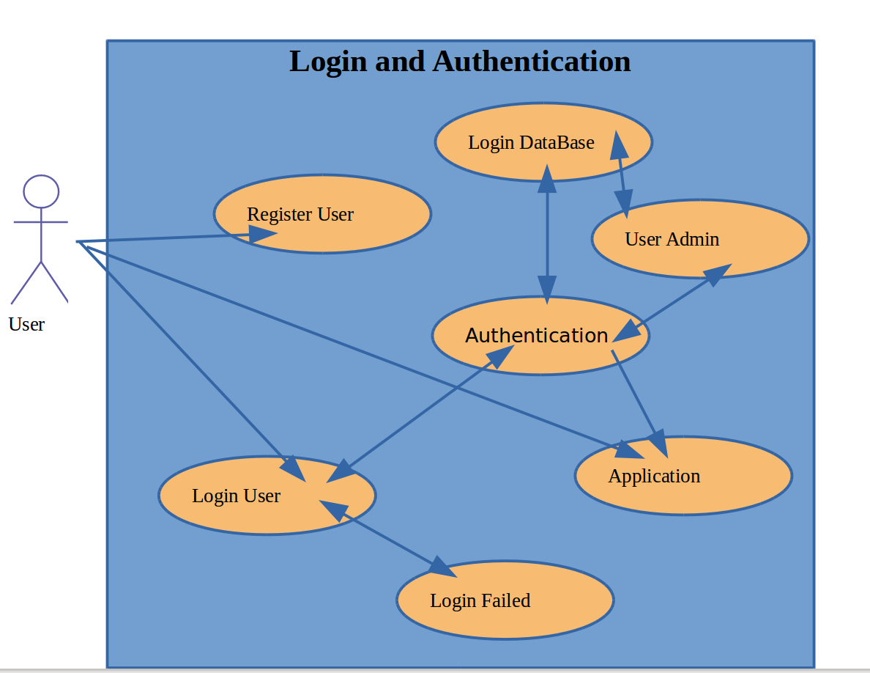

**Use Case context diagram**

**Class Diagram:**

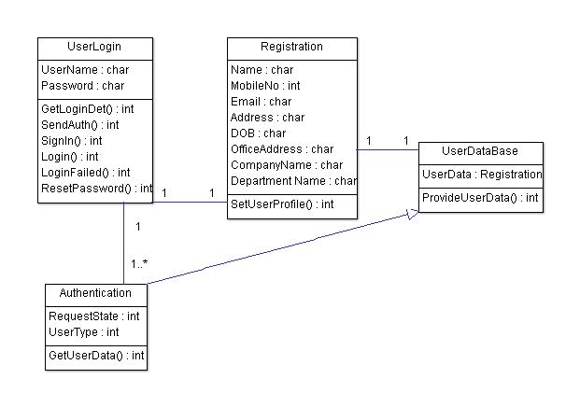

**SSD:**

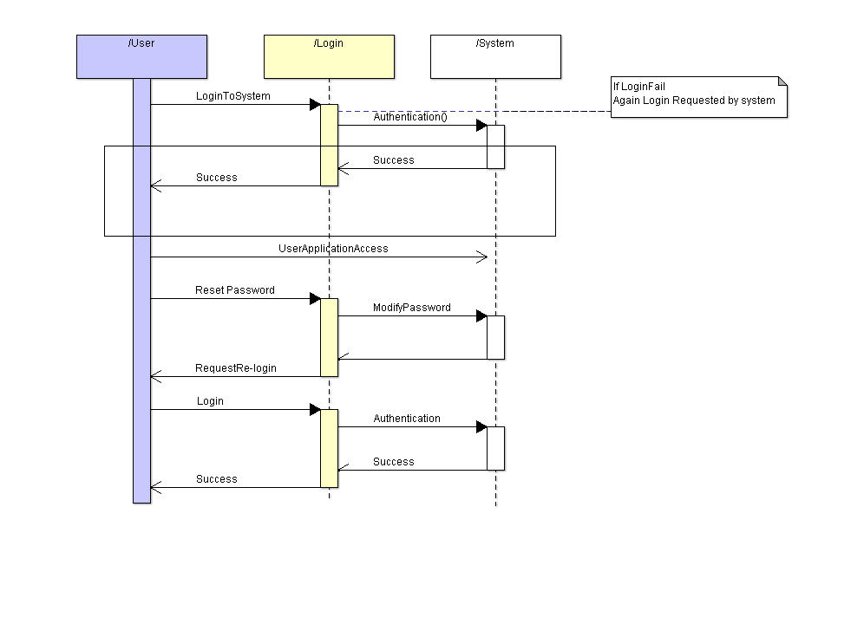

## UC1:Report Pothole:

**Scope:** Pothole Report

**Level:** User goal

**Primary Actors:** Citizen

**Stakeholder and Interests:**

-Citizen: wants easy option to report pothole, map should be integrate while reporting. After report a unique ID should be generated for tracking

-System: should identify unique request and assigned a unique ID for identification of pothole.

**Preconditions:** Citizen must be logged in.

**Success Guarantee:** After successful creation of request a unique ID should generated.

**Main success scenario (MSS):**

1. Citizen shall be able to add pothole details like address, landmark, GPS loc, photos, and pothole criticality.

2. The citizen shall be able to tag the located pothole on Google Map.

3. The citizen shall be able to create request by clicking a submit button

4. System shall generate unique ID.

**Extensions (or Alternative Flow):**

*a. If system logged out user, System shall allow again to login.

3a. User can save its request and submit later. User can re-login and again open it older saved request and submit.

**Class Diagram:**

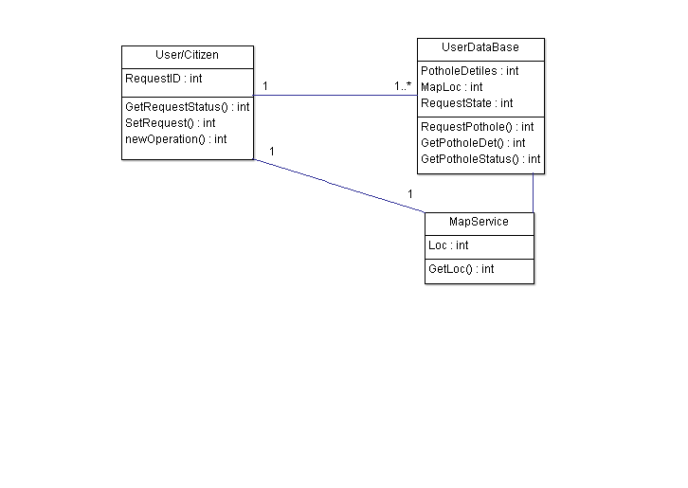

**SSD:**

